**University of Petroleum and Energy Studies**

School of Computer Science

Department of Cybernetics



**Graphics & Animation Tools**

**LAB FILE**

**(Session: 2020-2021)**

Course: B. Tech with Specialization in Open Source and Open Standards





**Experiment 6 : Design of 3D Hut using Blender.**

**Steps:**

1. Add a Cube mesh.

2. Apply subdivision to cut the cube in half vertically

3. In edit mode elongate the upper edge to make the roof shape.

4. Now extrude the roof a little normal to its plane and along its plane outwards.

5. Add colour to the hut.

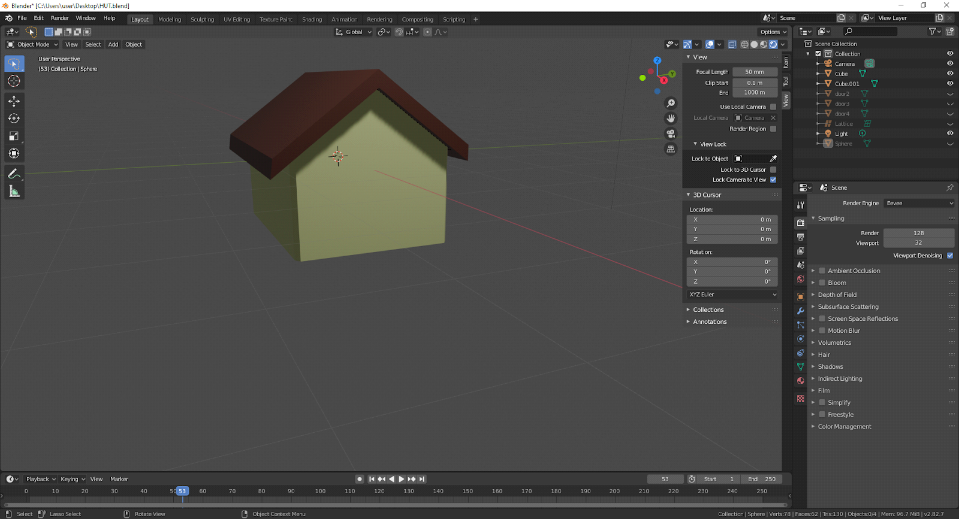

* Add a cube mesh and resize it to make a small cuboid.
* Make two more copies of the cuboid and arrange the three shapes to make the doorway
* Make 5 subdivisions of the upper cuboid and move the planes to make it slightly curved.
* Add colour to the door.

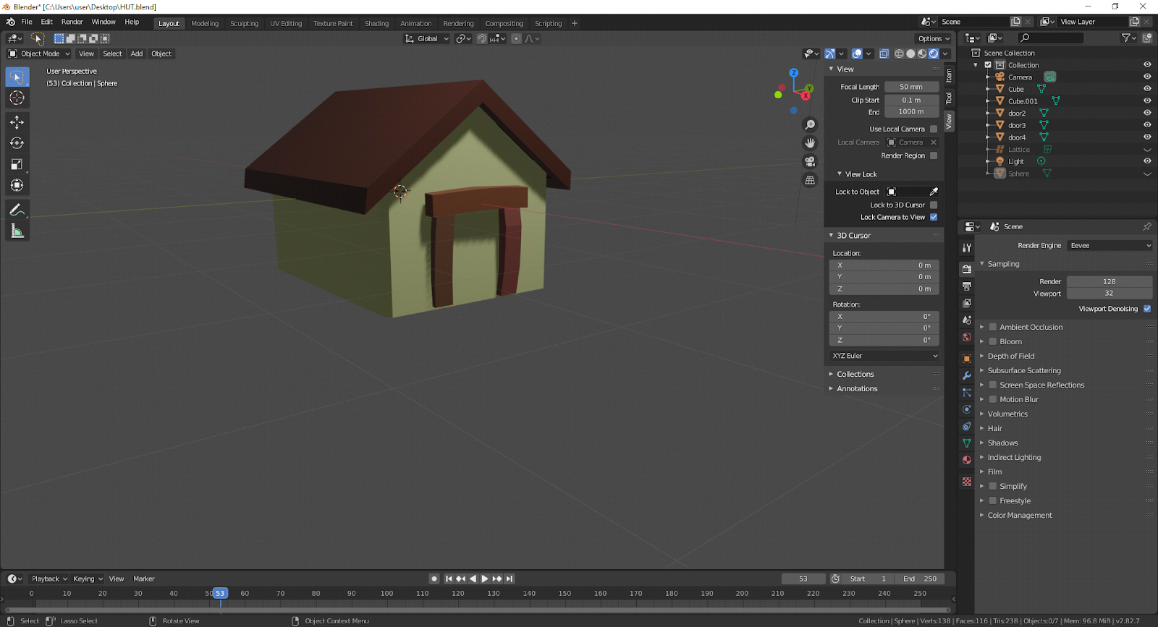

* Add a sphere mesh and resize it to its 8 times.
* Go into edit mode and select all the faces of the sphere except the upper three rows and delete them all.
* Select the top edges and move them down to flatten the upper surface of the sphere.
* Resize it and move it so that it touches the lower surface of the hut.

**Output :**

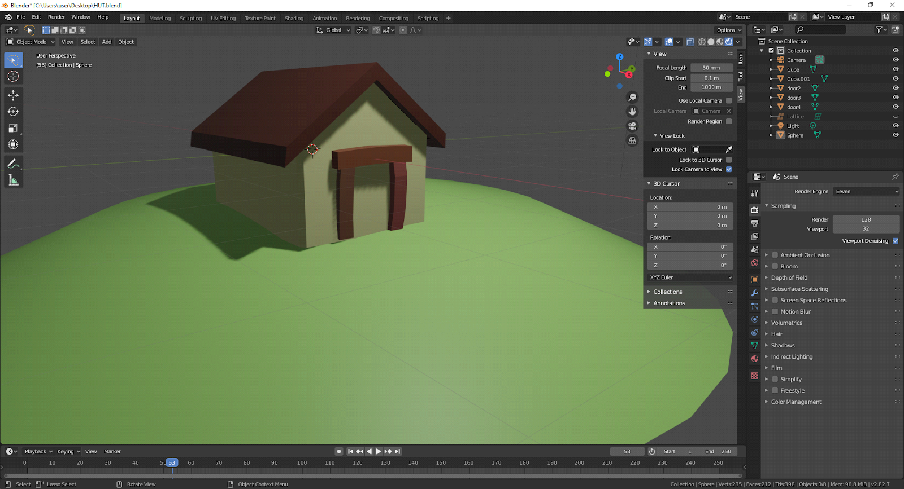

**Link to the Drive Folder :**

[**Graphics and Animation Tools**](https://drive.google.com/drive/folders/1L1gqtxnW8xDUk-jw3Z8dTLz2_Yth1-OI?usp=sharing)